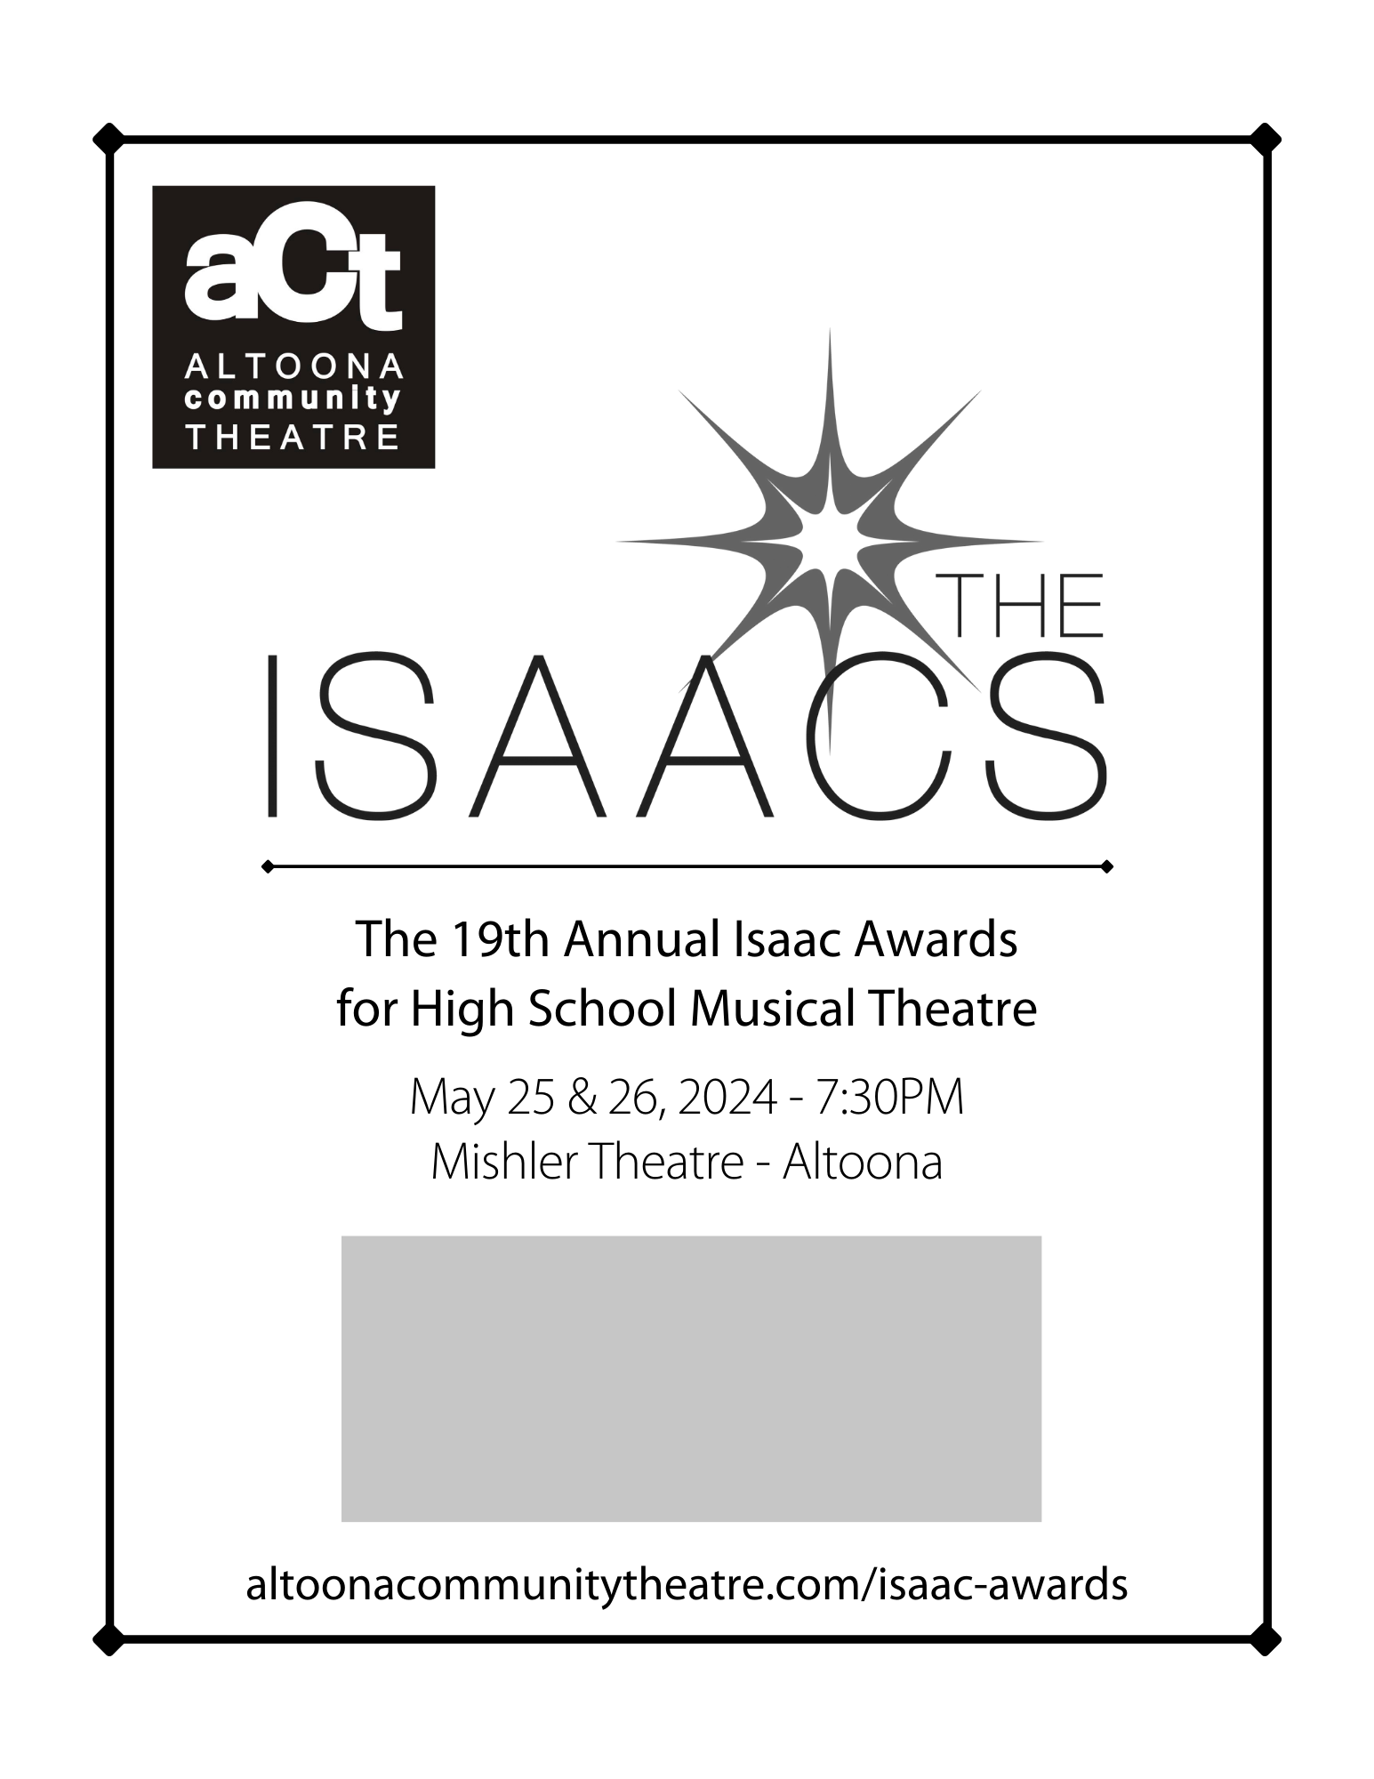

**Benjamin Franklin High School**

is a Proud Isaac Awards Participant

*2020 Best Dance Award*

*2021 Best Production – Runner Up*