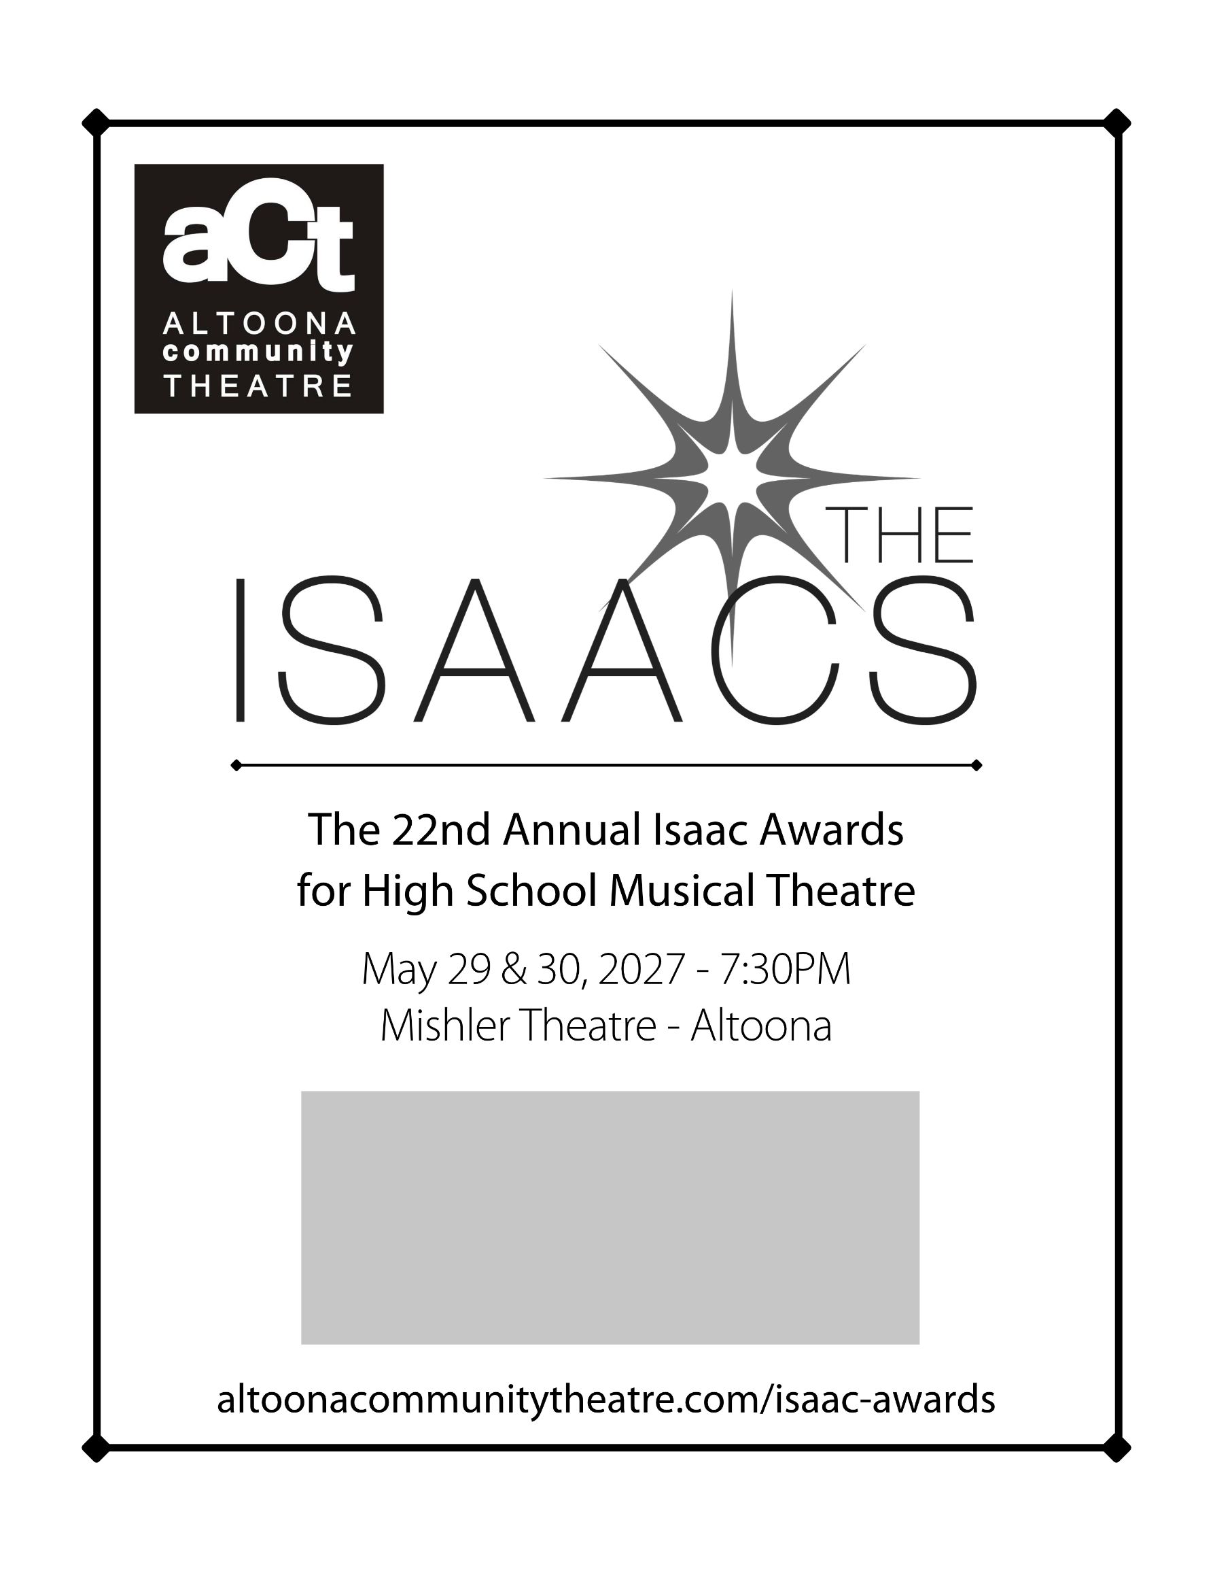
Benjamin Franklin High School
is a Proud Isaac Awards Participant

2020 Best Dance Award
2021 Best Production – Runner Up

